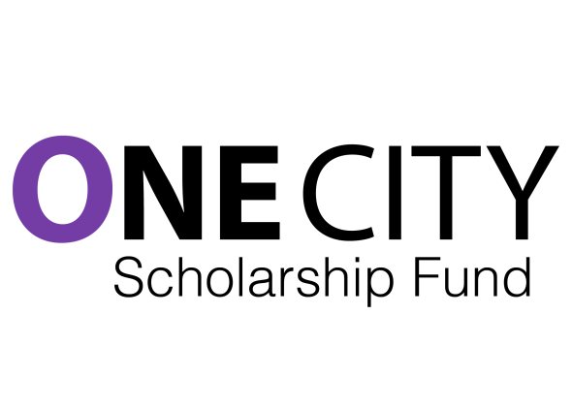
November 25th, 2015
Be a Founding Donor

Dear

Over the last six months a group of high school teachers in Toronto has been working hard to develop a scholarship to support remarkable students who have figured out how to excel while living in low socio-economic circumstances.

As a city, we need these young people to flourish; they have figured out something about resilience, focus and the power of optimism; they have figured out how to overcome doubt and stress and insecurity. On top of all that, they are really smart! They are potential power houses, who, with support, can shape this city into a place that is less divided, less wasteful of talent, less willing to be complacent about inequality.

But we need people like you to support them. Be a Founding Donor of the One City Scholarships.

We have established our scholarship under the auspices of the Toronto Foundation. Their business is to help people in this city implement their positive ideas. Help us. All donations over $25 are charitable and you will be provided with a charitable tax receipt.

Our initial goal is $25,000, which will put ourselves on the map and begin our multi-year journey to build a significant endowment and to begin providing scholarships soon that are substantial and multi-year for students attending university and college.

As our resources grow, we will increase the number and size of scholarships available; we will expand the kinds of supports and mentoring we are able to offer . We have ambitious plans for our students. It is time we got started.

Flourishing is not about getting by; it is about not having to worry about juggling the part-time job and classes; it is about being able to dedicate oneself to one's studies, to one's development, to take advantage of opportunities that will expand horizons.

One City Scholarships is about supporting remarkable students, but it is also about changing the narrative in this city about the young people who are living in poor neighbourhoods. So many of them are remarkable, so many of them are amazing. I can tell you it is a true honour to teach these students. What we can offer them is an open-heart, and the willingness to offer support.

When we reach across the barriers that divide us, we become one city.

Yours truly,
Will Wallace
Steering Committee Chair
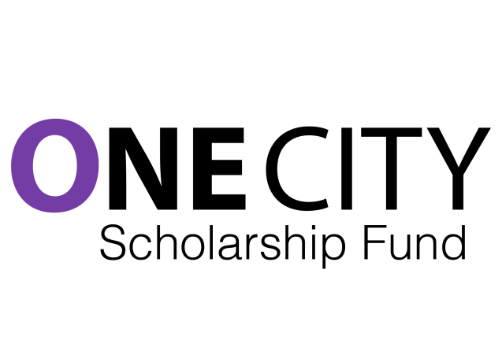
Become a Founding Donor:

- Founding Supporter $250-$999
- Founding Builder $1000+
- Supporter $25-$249

All donations of $25 or more will receive a charitable receipt.

To make a donation:

Visit our website at www.onecityfund.com and click on donate to be linked to the Toronto Foundation's secure website.

One City Scholarships is a project by teachers and their community partners for students in collaboration with the Toronto Foundation and the Toronto Foundation for Student Success. The members of the Steering Committee are:

Matt Chapman, Monica de Jersey, Lisa Garby, Gemsy Joseph, Mia London, Sarah Pole, Lisa Prinn, Natalia Simone, Nastassia Subban, Will Wallace (Chair)

When we reach across the barriers that divide us, we become one city.

